Logged into the Acadgild 32-bit VM. Started the daemons.

Task 1

Checked if /user/acadgild existed.

It was existing.

Created /user/acadgild/Hadoop

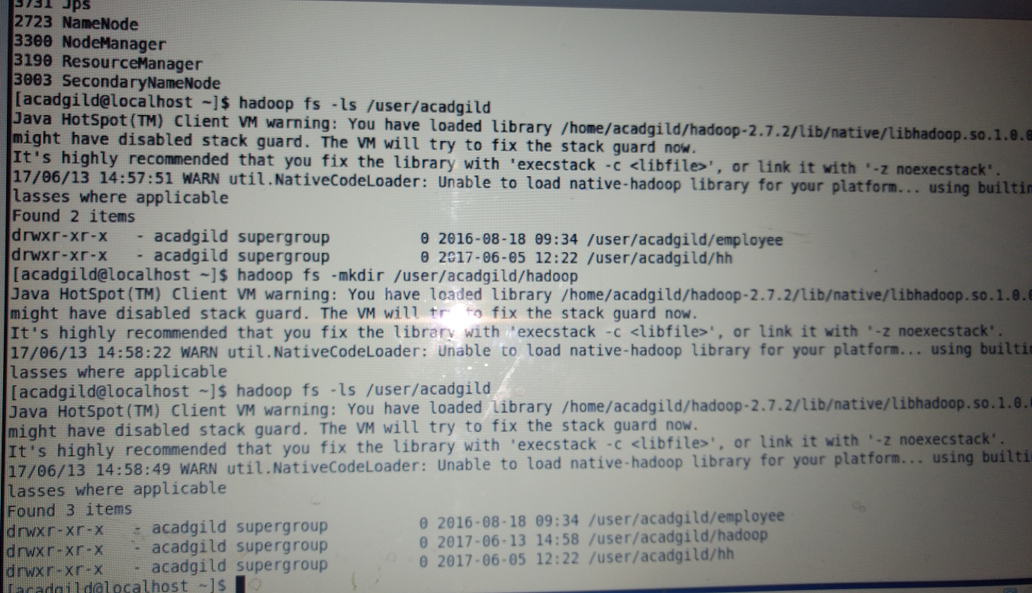

Contd. Task 2

Create the dir /user/acadgild/Hadoop/word.count.txt

Append contents to the file

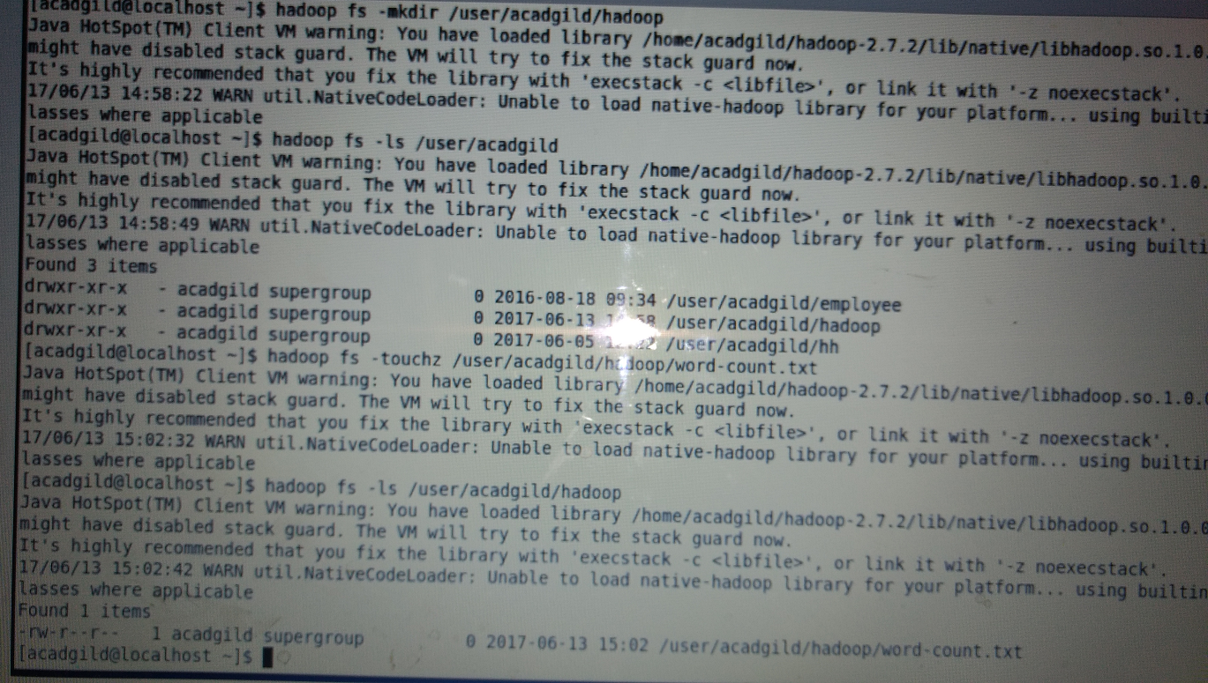

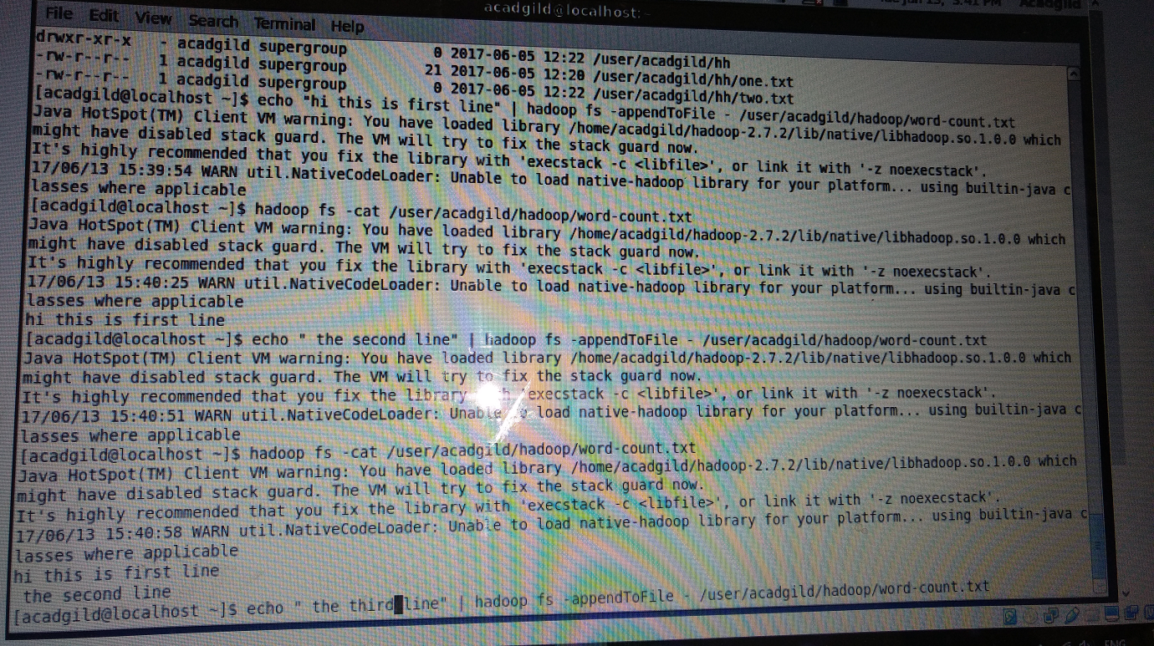

The contents of the file shown below screenshot.

